
ASSIGNMENT-2
School of Engineering and Technology
Course Code & Name: ENCS304 Computer Networks
Program Name: B.Tech CSE

Name: Amandeep
Roll Number: 2301010200
Course: BTech CSE – C

Packet Flow Visualization Using Simulation Mode
Experiment Objectives:
Students will use Packet Tracer Simulation Mode to observe how packets move between devices, how switches learn MAC addresses, and how ICMP echo request/reply travels through a small network.
Learning Outcomes
- Use Simulation Mode effectively
- Observe ARP + ICMP behavior
- Understand switch MAC learning behavior
- Interpret packet event list timeline
Concepts Used
- Simulation Mode
- ICMP ping
- ARP resolution
- Switch MAC address table learning

Objective
The objective of this experiment is to understand how packets travel across a network using Simulation Mode in Cisco Packet Tracer. It also demonstrates ARP resolution, ICMP communication, and how switches learn MAC addresses.

Task 1: Building a Simple LAN
A simple Local Area Network (LAN) was created using:
- 1 Switch
- 3 PCs
IP Configuration
- PC1 → 192.168.20.1 /24
- PC2 → 192.168.20.2 /24
- PC3 → 192.168.20.3 /24
All devices were connected to the switch using straight-through cables.

Task 2: First Ping Observation (PC1 → PC2)
Simulation Mode was enabled and a ping was sent from PC1 to PC2.
Observed Behavior
- ARP Request
  - PC1 did not know the MAC address of PC2.
  - It sent an ARP Request (broadcast) to all devices in the network.
  - The switch forwarded this broadcast frame to all ports except the source port.
- ARP Reply
  - PC2 responded with its MAC address using an ARP Reply (unicast) to PC1.
  - The switch forwarded this reply directly to PC1.
- ICMP Echo Request
  - After ARP resolution, PC1 sent an ICMP Echo Request (ping) to PC2.
- ICMP Echo Reply
  - PC2 responded with an ICMP Echo Reply.
  - Communication was successfully completed.
Switch Behavior
- The switch learned MAC addresses by observing incoming frames.
- It stored:
  - PC1 MAC → Port X
  - PC2 MAC → Port Y

Task 3: Second Ping Observation (PC1 → PC2)
A second ping was sent from PC1 to PC2.
Observed Behavior
- No ARP request was generated.
- Only:
  - ICMP Echo Request
  - ICMP Echo Reply
Reason
- PC1 already had PC2’s MAC address stored in its ARP cache.
- The switch also had MAC entries in its MAC address table.
Conclusion
- The second ping was faster and involved fewer packets.

Task 4: MAC Address Table Observation
The switch MAC address table was checked (or inferred through simulation events).
Observations
- The switch dynamically learned MAC addresses of connected PCs.
- Entries included:
  - MAC address of PC1 mapped to its port
  - MAC address of PC2 mapped to its port
Learning Mechanism
- When a frame arrives, the switch records:
  - Source MAC address
  - Incoming port

Screenshots
Setup
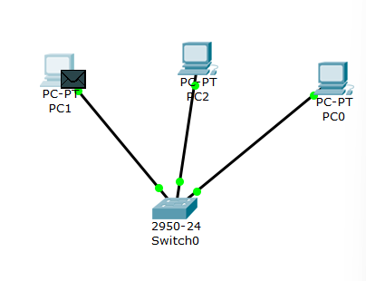
Ping
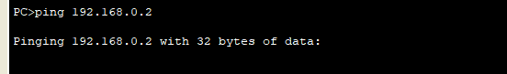

transmission chronology
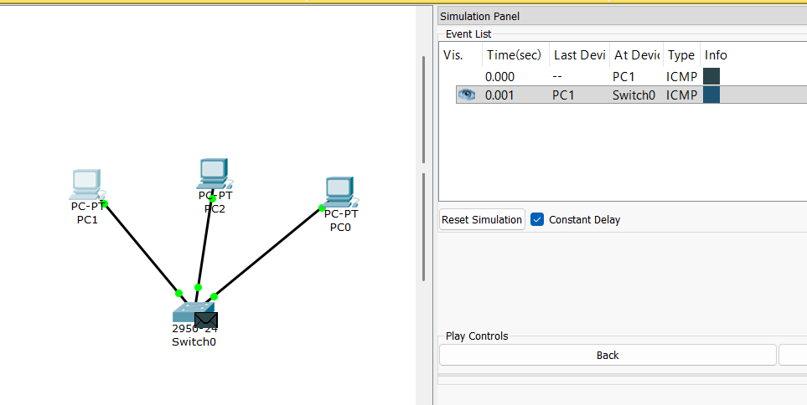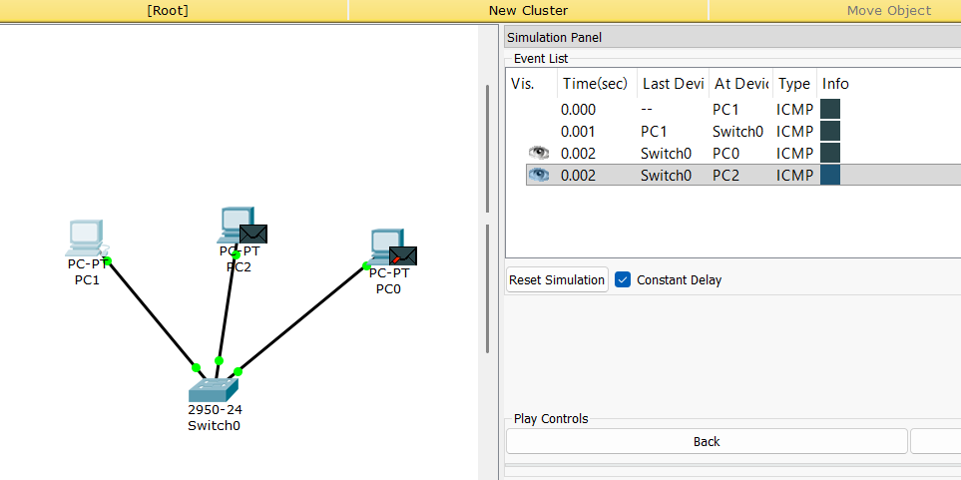
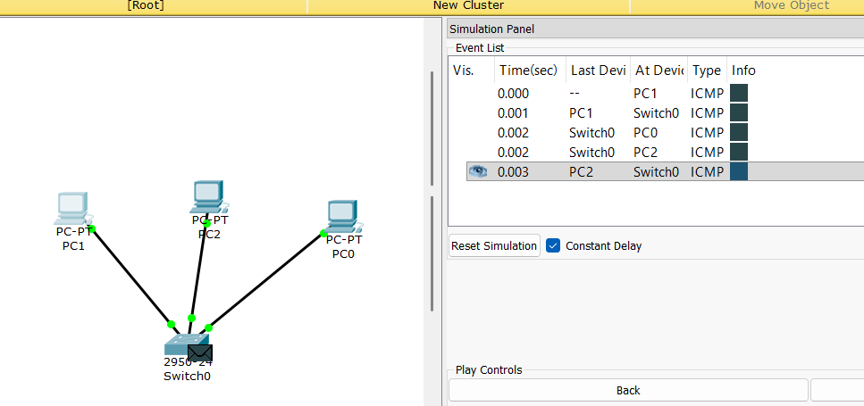
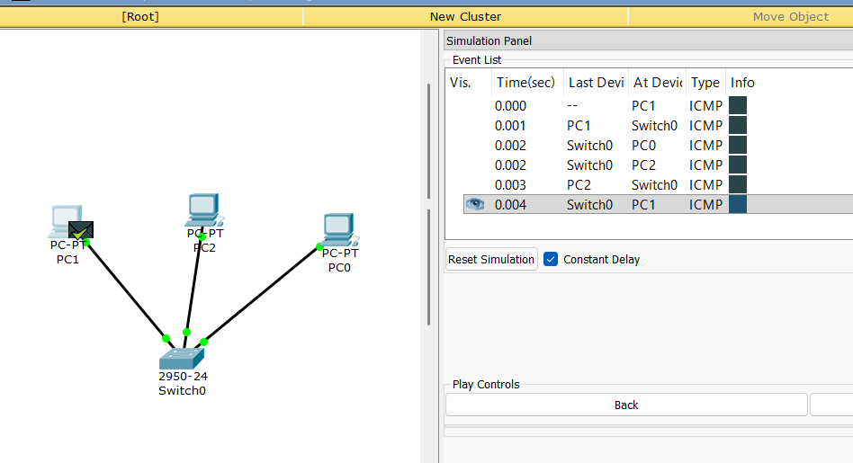
Packet received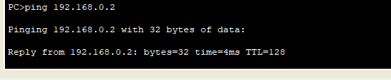

Sending packet again after caching

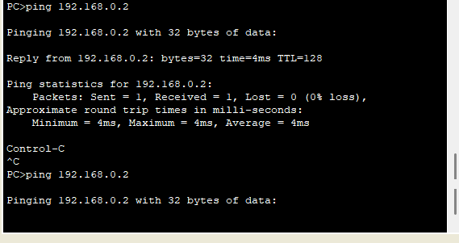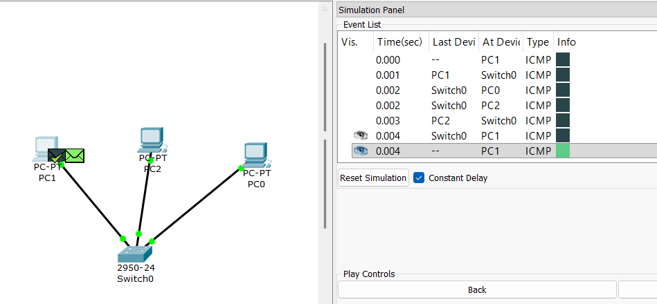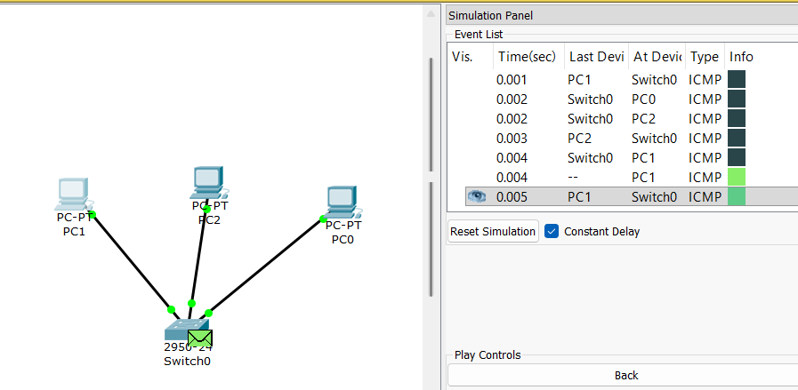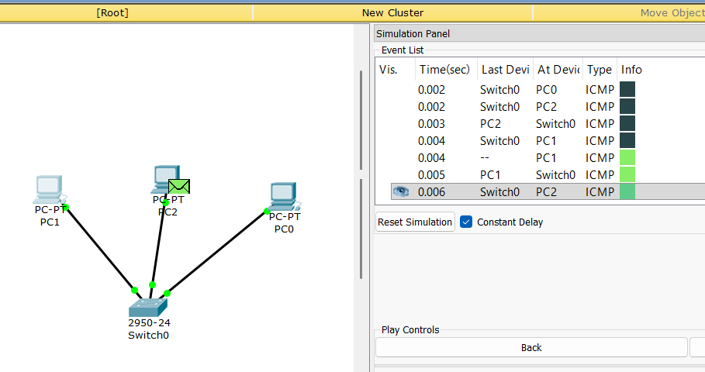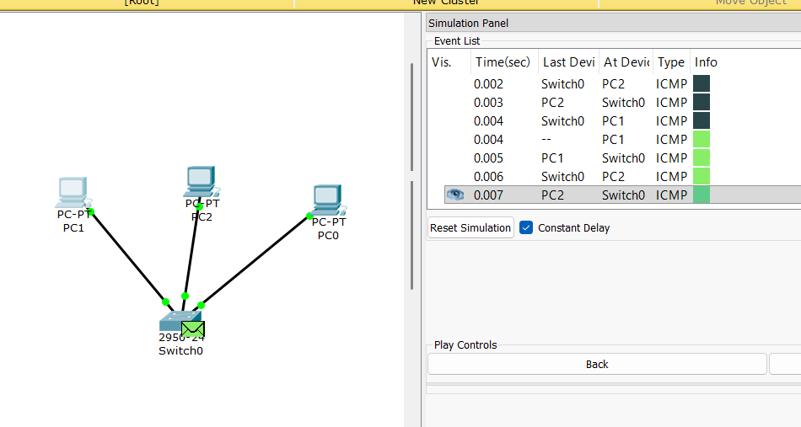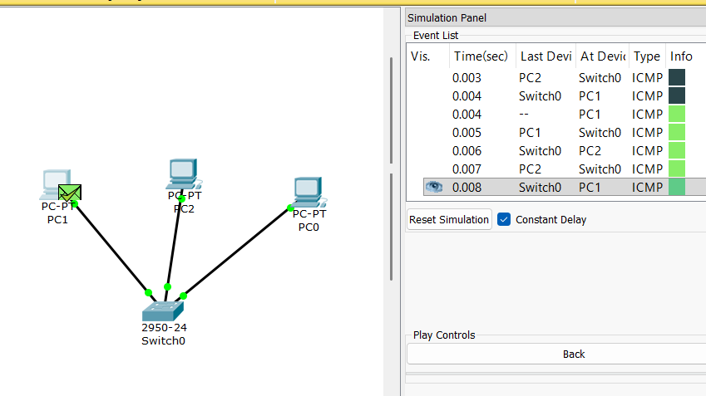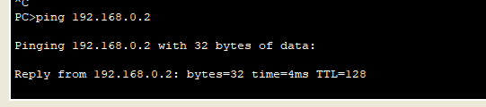
Packet received
Switch table (after caching)
